A man has took a shop in Rent near BTM Layout, Bangalore, not in the main road but as a local shop. The rent of the shop is 14000 per month. The man took the shop to sell fast food like - Biryani, Maggie, Egg Bhujia, Omlets, Chicken Kabab etc.

a. In the first 3 months he make a profit of around 100000, with a sales of around 300000.

b. In the 1st month he was selling veg food also, but he stopped after the 2nd month as it stock was not getting out.

c. After 4 – 5 months down the line the man is making a huge loss in his investment. He has a due of 2 months to pay the rent.

d. The sale has drastically gone down and he is thinking to close the shop.

e. The Man is very lazy in working hard and also very poor in any other investment.

How will you tackle a situation of this kind? Write a solution to this kind of problem. Give a Fact-full answer by understanding the critical prob

Ans: Sample Data

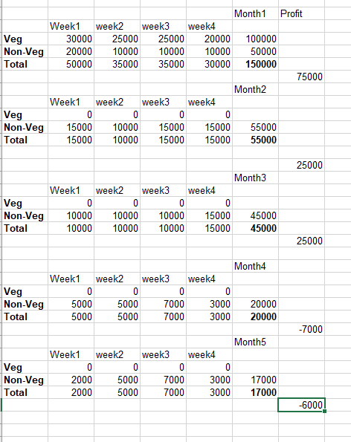

1.In that area Shops are open early and closing late. This man too lazy because of that not maintaining timings.

2.he don’t have funds to get stocks basically 1st month he is selling veg food more compared to nonveg from 2nd month onwards he stopped because of funds problem.

3.from 2nd month onwards he is selling only nonveg foods in that area mostly likes veg food, because of that 2nd month onwards his sales and profit also going down.

4.in his shop some nonveg food wasting since 1st month onwards that area not much preferred in nonveg food items.

5.still his continuously waste food and no funds to buy stocks from 4th month what his having stock his selling those only because of that 4th and 5th his sales are going down and getting losses.